Zachary Hisley
Justin Whiteside
CMSC471
12/19/2013
CMSC471 Project Writeup

- Traveling Salesman Problem
  - Our baseline method for this problem assumes that given the current city, a random city from all of the available ones will be chosen as the next destination until all cities are visited and the original city is returned to. In our code, we used the algorithm Max provided, in which a random file is generated, and then the cities are traversed in the order generated and the total distance is calculated, essentially a randomized path. This is a very naïve method as it provides no form of optimization, instead relying on completely random choices, which does not at all help the goal of trying to find the shortest possible path.
  - To improve this method, we decided to use Dijkstra’s algorithm. In this algorithm, given the current city, the city that is the shortest distance away will be the next one chosen, until all cities are visited and the original city is returned to. In our code, a random file is still generated, but using Dijkstra’s algorithm, a list of cities is sorted by the shortest distance from the current city, and the new “solution” list is then traversed to calculate the total distance. We believe our new method will do better, because this algorithm attempts to find an optimal solution by using an informed (greedy) approach to traversing the cities.
  - The results of our algorithm support our theory that Dijkstra’s algorithm would perform better than a random traversal of the cities. Our results are shown in the following graph:

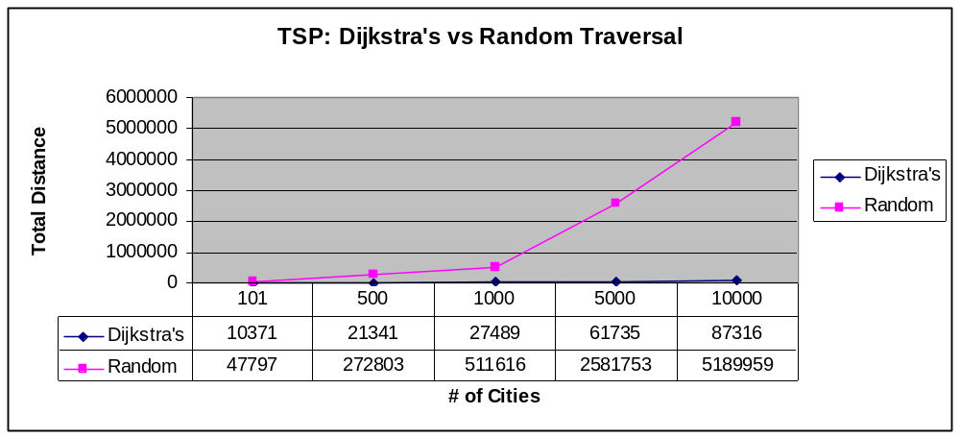

As you can see from these results, Dijkstra’s algorithm performed significantly better than a random traversal of the cities. Dijkstra’s algorithm also performed significantly better in terms of scaling, doing so in a somewhat linear fashion, while the Random traversal begins to scale much more rapidly as the problem size increases.

